**Q6. Japanese Cities' Names**

Query the names of all the Japanese cities in the CITY table. The COUNTRYCODE for Japan is JPN.

The CITY table is described as follows:

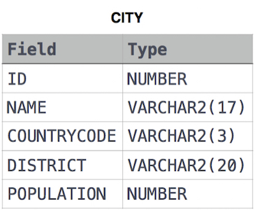

Ans.

SELECT NAME

FROM CITY

WHERE COUNTRYCODE = 'JPN'